**Abstract**

The Pwani Innovation Week hackathon, organized by Tabiya, focused on connecting individuals with jobs based on their skillset rather than educational background. The hackathon aimed to improve Tabiya’s existing tools, Compass AI and Taxonomy, which provide skills analysis and a dataset of occupations and skillsets. The winning team, Elimu, developed Skill Navigator, a solution that analyzes CVs, identifies skills gaps, and recommends educational paths to address those gaps. Skill Navigator also improves the Taxonomy dataset by adding job occupations common in Sub-Saharan Africa and creates a job pool for potential employers. The team proposed using the $1500 prize money to purchase personal computers for the participating students.

**Introduction**

The pwani innovation week is an event that brings all innovation across east africa and beyond aiming to focus on exposing youths to innovation , linkages and partnership. This is achieved through creation of mentorship sessions, masterclasses for various contemporary issues and hackathons to allow youths to flex their skills on how they understand the local challenges and how innovative they are to offer solutions stemming from the identified challenges. It is a one week event happening at swahilipot hub in mombasa bringing all youths from kenya, colleges eg north coast medical college, Technical university of mombasa, kenya coast national polytechnic,Taita Taveta university, mount kenya university, Pwani university and Taita Taveta National Polytechnic. This is not only the full list but various experienced and solo developers from well established tech companies also attend to identify ideas and potential unique solutions for them to fund or implement.

**Subject of the hackathon**

The hackathon was organized by Tabiya which is an non-profit organization established at the university of oxford and headquartered in washington DC. Their aim is to create a way in which anybody is able to get connected with jobs regardless of their educational background neither high school, college diploma,certificate,degree or master but it only recognizes the skillset one possesses. This is achieved through their compass AI that is able to provide near perfect skills analysis by allowing the individual to have a conversation with it and it will prompt questions that will enable the job seeker to accurately and honestly give input relating to his job experience level. The person will give any job he/she has done in her life even if it is taking care of a sick parent or sibling or volunteering position or formal employment , the year the location the tools how your everyday work life looks like and give a pdf of your Cv containing all your experience and skills.

They again have a tool called taxonomy which is a dataset containing about 4000 occupations and 14000 skill sets as per the European Union where an employer can clearly define the job position he is hiring for.

**Problem**

Based on the above provided tools we realized that  
1. The taxonomy has missing job occupation that are found in sub-saharan africa   
2. The different synonyms for jobs in europe and africa

3. Lack of dedicated job pool to match job seekers and potential employers and recommended learning path for gap in skills

**Solution (SKill Navigator)**

After thorough analysis and problem identification

The team came with the following solution

1.Created a way in which the skills from the CV can be analyzed and the job seeker with his skills can be placed in a job bank for potential employers

2. Created a way in which we are able to improve the Taxonomy dataset to allow it be able to understand the job that are not common in europe but are actual job in kenya and sub saharan africa

3.Created away in which potential employer can see the job seeker from the pool and get to hire one which has the skills he or she needs in needed occupation

3. Cv analysis. The Cv after being analyzed the skills gap are being identified and our solution can provide recommendations on the education path one can pursue to enhance the missing skills.  
5. Created away in which jobs can be filtered in terms of location and nature (everyday jobs eg mjengo, laundry person)

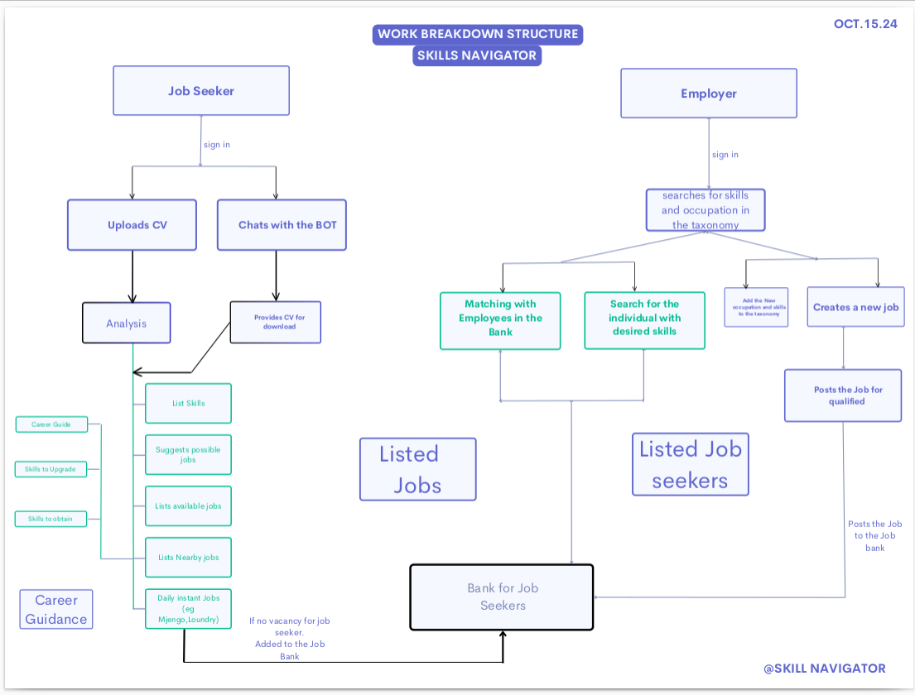

**Next step**  
The Tabiya team promised to help us build this with their tech team(developers) and roll it to the market as a hiring agency and job connector. It had several advantages compared to the current job matching platform. Currently we are in touch with their developers team and we are mapping where to begin.

**Prize**  
The prize money won was $1500

Proposed use of the money

Students that participated were so thrilled and motivated, they realized that they need to do more and since they lack computers when they go back home since all computers must be left at the center. They proposed that the prize money be used in buying them personal computers to help them continue and learn more and help in developing their skills as well us in building the project.

**The team**  
Khadija Uzeir digitech cohort 2

ELiud anyoka digitech cohort 1

Seth makori Friend to elimu(community member)

ELina Kadzo digitech cohort 2

Ogola Evance (team leader)/digitech instructor

Seth makori is a community member,he interacted with Elimu during the digitech launch and hackathon and has since loved what we do at Elimu and he joined us for the hackathon

They are on their linkedin post  
[linkedin post](https://www.linkedin.com/company/tabiya/posts/?feedView=all)

**Participation**

Participation consisted of various teams and different elimination stages.

The first phase consisted of 25 teams,after which they did elimination from submitted ideas and remained with 20 teams to the second round.

The second round submission consisted of 20 teams after which they eliminated 5 teams and 15 teams proceeded to the third and final round.

The participants generally were from universities and well established colleges comprising of kenyans citizens

**Other useful information**

